Neonicotinoids; how to cope without seed dressings in rape

By now, every oilseed rape grower will be familiar with the ban on neonicotinoid seed treatments in rape. Despite having been around for over 15 years in various products, the insecticidal dressings have arguably been one of the most under-appreciated tools in crop protection.
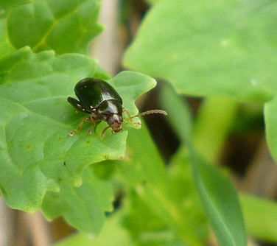
What are the threats?
As a consequence of their loss, we believe that autumn 2014 will come as a shock to many, proving just how important these seed dressings have been in ensuring even, reliable rape establishment.
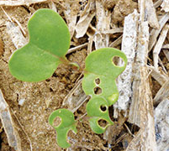
The ban effects both Cruiser and Modesto seed dressings, both of which provided around 8 weeks protection again a range of pests including Flea Beetle and Turnip Saw Fly caterpillars.
Those who can remember growing rape – or indeed linseed or forage brassicas without treated seed – will have their own experiences of cotyledons being eaten off before they have barely emerged
Whilst Flea Beetle, and the characteristic “shot-hole” damage that they cause is highly visible, in recent years researchers have also highlighted another potentially very damaging pest; the humble aphid.
Images courtesy of Farmers Weekly
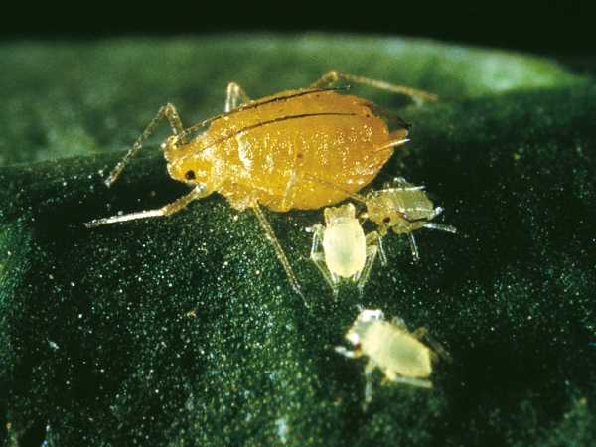
Just like Barley Yellow Dwarf Virus in cereals, aphids can transmit Turnips Yellows Virus (TuYV) in oilseed rape, and this will necessitate a different approach to protection rape in the autumn. We examine both pests, and how growers should react this autumn.

Image courtesy of Bayer
Flea Beetle

HGCA Flea Beetle thresholds
1-2 leaf stage - 25% of leaf area eaten
3-4 leaf stage – 50% of leaf area eaten
2 larvae per plant / larvae in 50% of petioles
The overriding message is that crops need to go into good, consolidated seedbeds with moisture. Monitoring has to begin immediately, with growers prepared to spray at the thresholds (see right hand box). Pyrethroids such as Toppel and Permasect are perfectly adequate and relatively inexpensive. Monitoring must continue after spraying however, as there is almost no persistence, and Flea Beetle attacks often re-occur very quickly.
- Cultivations – A good seed bed is important in maximizing seed-soil contact – ie. a fine crumb structure will aid establishment. Seed should be sown at 2-3 cm and rolling is recommended to retain moisture. Not only will this help the crop to grow away from CSFB but it will also reduce the risk of slug damage. DO NOT DRILL If seed beds are very dry and cobbly, wait for more suitable conditions before drilling
- Sowing date – Winter oilseed rape is typically drilled between mid-August and mid-September in England and Wales. High yields can be achieved from drilling anytime between mid-August and mid-September. The chance of significant yield reduction only becomes more likely for crops drilled after mid-September. Crops sown mid-August will take about 7-10 days to emerge compared with 10-14 days for those sown in the second half of September. Flea beetle damage is often worse in August emerging crops particularly when conditions are dry & warm.
- Seed Rate - Use an appropriate seed rate 70-80 seeds/m2 for conventional varieties – 40 seeds/m2 of a hybrid is highly risky. Increasing seed rates above 80 seeds/m2 is unlikely to be beneficial & may lead to over-thick canopies if damage is minimal
- Seedbed N - Consider placing a starter fertiliser with the drill if possible or apply N to the seedbed ahead of drilling to ensure it is available to seedlings from emergence
- Seed Dressings - Mesurol seed dressing offers limited protection (see box below)
Mesurol seed treatment
Mesurol is NOT a neonicotinoid, and provides very limited activity (1-2 weeks max) on Flea Beetle only. Evidence suggests that it can slightly delay emergence.

Cabbage Stem Flea Beetle (CSFB) Control
Currently pyrethroid insecticides are the only alternative to neonicotinoid seed treatments for control of CSFB adults and larvae. CSFB resistant to pyrethroids have been recorded in Germany so there is a risk that this could spread to the UK - an HGCA funded project is currently investigating the extent of pyrethroid resistance in CSFB in the UK. With the threat of resistance, it is therefore vital that pyrethroids are used only if needed for the control of CSFB to minimise the potential development and/or further spread of resistance (see HGCA control threshold box above).

Turnip Yellows Virus (TuYV)
Spread by the Peach Potato Aphid, these fly into crops to feed, and in doing so, infect the plants with the virus. Interestingly, researchers have found that up to 72% of these aphids already carry the virus – so even where seed treatments were used in the past, by the time the aphid has begun feeding and taken up a lethal dose of insecticide, it has already infected the plant!
For this reason, it is very hard to estimate how much yield has been lost to TuYV in the past, and it is also almost impossible to see in the field. The yield loss has been estimated at 10-15%, but studies have shown up to 40% yield loss.
99% of aphids are resistant to pyrethroids such as Toppel or Hallmark, and the only product which will control the aphids is Plenum. Monitoring is crucial – firstly to get the timing correct – and secondly, because there is very little persistence and only one application is allowed in the autumn.
The only form of cultural control is growing a resistant variety, which currently includes just a single variety, Amalie. No thresholds for spraying currently exist, but the key message is that aphids will need careful monitoring from the 3 leaf stage. Rothamsted suction trap reports will also help guide us.
What about beneficial insects?
NIAB TAG trials over two season in Kent actually showed the pyrethroids such as Hallmark – largely ineffective against Peach Potato aphids due to resistance – can actually increase TuYV infection. The likely explanation appears to be that more natural predators of the aphids are killed than the aphids themselves.
Thankfully, Plenum is classed as Low Risk to arthropod species; Ground Beetles, Ladybirds, Spiders and other aphid parasitoids.

Routine sprays at the first sign of damage must be avoided.
Key points:
- Seedbed quality is as important as ever
- Choose an appropriate seed rate on the day of drilling
- Drill into moisture & roll ASAP
- Monitor crops immediately for signs of Flea Beetle
- Monitor for aphids from 3 leaf stage onwards
- Do not spray unless absolutely necessary

