CCC Soil Nitrogen Newsletter
March 2014

Last year’s soil nitrogen levels were low. But few would have imagined that one of the wettest winters in living memory would have been succeeded by another winter of biblical rainfall.
At the time of writing however, the key differences to last year have been firstly, the absence of pigeons, and secondly generally mild temperatures – both of which have allowed continued crop growth throughout the winter, where crops have not been waterlogged, which poses some interesting questions for nitrogen management.
A quick analysis of the 63 deep nitrogen tests taken this year underlines the importance of understanding what effect this has had on soil nitrogen levels. As the graph below highlights, winter wheat crops generally have very low Soil Mineral Nitrogen (SMN) levels compared to recent years – about 15-20 kg/ha lower (some up to 40 Kg/ha) – resulting from high leaching losses. Winter rape fields however showed a different story, which has important implications for deciding on the final nitrogen dose to achieve the correct total application rate.

In contrast of the trend of low soil nitrogen levels in the wheat this year, oilseed rape fields are generally showing higher levels of SMN as the above graph demonstrates. Typically oilseed rape fields this year contain around 25-40kg/ha more nitrogen than the beginning of 2013, which is of course puzzling given the amount of rainfall and potential leaching losses.

Why is there so much more Nitrogen available than last year? It is hard to escape the fact that as crops have grown continuously and developed thick canopies in most fields, as the Soil Nitrogen Supply (SNS) graph to the left illustrates. The SNS takes into account not only what is in the soil, but also the nitrogen within the crop. Naturally, the kind autumn meant that a large amount of nitrogen was taken up by crops before significant leaching had occurred.
“Oilseed rape canopies typically hold 50-60 kg of nitrogen for every unit of Leaf Area Index”

So there wasn’t necessarily any more nitrogen in the ground to start with this year (except where previous wheat yields were below expectation last season) but crops were better able to utilise what was there.
That said, more rape fields probably received autumn nitrogen this year in response to the poor autumn of 2012, and crucially, a higher proportion of sampled rape fields received organic manure (either poultry muck or sewage sludge) for the same reason. This effect is shown clearly in the final graph below.

This explains why there is more nitrogen both in the crop and in the soil, as organic nitrogen is released more slowly and hence is available over a longer period, being less prone to leaching. A key difference between this spring and last was the effect that pigeons had at removing crop leaves – and of course nitrogen. When all of the results are laid out side by side in the graph, we can build a picture of the nitrogen situation in a typical wheat or rape field, with or without manure applied.
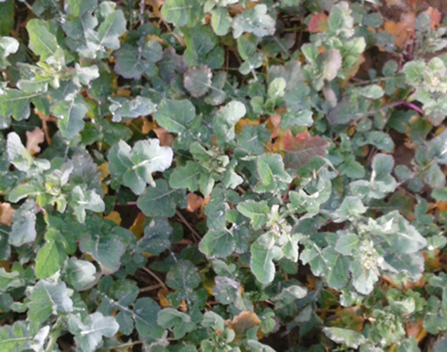
With often around 100-plus kilograms of nitrogen in the crop canopy alone this spring, there is clearly scope to reduce nitrogen applications in rape crops, to achieve the target Leaf Area Index of 3.5 by flowering, the optimum dose could be around 150-180 kg /ha of N on many crops.
With lower levels of Nitrogen in wheat crops however, growers will need to apply toward the higher end of their planned fertiliser input or in some cases above.
Growers should always take account of the nitrogen applied in organic manures, and to stay within the NMAX for the crop.

Key messages for 2014
- Soil nitrogen levels are around 15 – 20 kg/ha lower in wheat fields than last year. Nitrogen rates will need to be maintained in most situations.
- Oilseed rape fields have significant scope to reduce the final nitrogen dose, where the crop canopy is large.
- Calculations must take account of nitrogen applied in organic manures.
- Please retain this document with your NVZ records for justification of nitrogen application rates.

Wheat Fungicide Management Pointers 2014
Please be aware that fungicide program costs will be notably higher than in recently years, due to a combination of higher disease levels, more forward crops, and a background of reducing triazole fungicide efficacy against Septoria tritici. Higher Eyespot risk and greater Septoria pressure in the more forward crops will necessitate increased use of the new generation of SDHI fungicides; a number of respected independent researchers have highlighted the cost effectiveness of these programs over lower cost alternatives, even in lower disease pressure years and at lower grain prices down to £100/t – spray programmes in the more disease prone varieties such as Gallant, Solstice & Cordiale are likely to add up to a total spend of up to £125/ha.

